Mutual Alert | 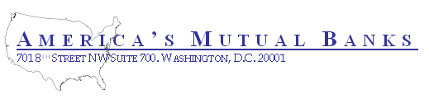

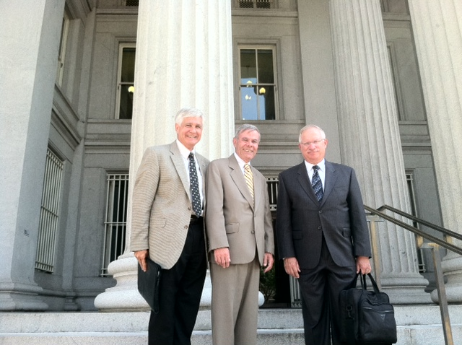
AMB members Jay Ford, Crest Savings, Bill McGarry, Ridgewood Savings and Fred Schea, First Savings Bank of Perkasie leaving the U.S. Treasury Department after a meeting with Deputy Assistant Secretary of Financial Institutions Lance Auer to voice the concerns of mutual banks.
America’s Mutual Banks meets with U.S. Treasury Department
Today members of AMB met with Treasury Deputy Assistant Secretary of Financial Institutions Lance Auer to discuss the issues important to America’s mutual banks. The meeting was cordial and informational in nature. The members explained to the Secretary the reasons for the formation of AMB and its mission to give voice to the concerns of mutuals. In addition to those pictured above Doug Faucette and John Bruno were in attendance.

Secretary Auer apologized for the Deputy Secretary Wolin who was forced to miss the meeting because of the ongoing Treasury negotiations. Mr. Faucette thanked Secretary Auer for his time and willingness to entertain our concerns. Mr. Faucette summarized the various talking points that are contained in the attached agenda. In response to the Secretary’s inquiry as to our principal objective, we explained the increasing number of incidences where the agencies have overlooked the mutual form of governance by adopting policies or regulations which are incompatible with the mutual form. Examples were given and a discussion took place over the need for the OCC to reaffirm a prior OTS supervisory directive to examiners to make reasonable distinctions between the mutual and stock form. Bill McGarry related examples of examiners not being able to make sound comparisons and management time expended in explaining basic differences in the mutual mode of operation from stock operations. Doug Faucette explained the dangers of lessening protections against professionals taking control of the Board of Directors of mutuals and forcing conversion or diverting their assets for personal gain. Some concern was expressed for preserving the prerogatives of the mutual savings and loan association’s board of directors in controlling the governance of the association as the preferred stewards.

There was also a lengthy discussion on the need of mutuals for alternative capital instruments. The Secretary while indicating Treasury absence of support for the Collins amendment expressed doubt that any legislative relief was available in the near future. However he agreed that alternative capital instruments for mutuals would be a more palatable proposal and not a bad place to start politically. Fred Shea indicated that his institution would be disadvantaged without the ability to issue TRUPs or other forms of capital instrument. Jay Ford indicated he already was contemplating leveraging his mutual holding company so long as he could avail himself of the under $500 million assets consolidated capital exemption.

Doug Faucette complemented Treasury for influencing the Fed to accept TARP subordinated debt as Tier 1 capital and exclude subordinated debt from the 30 to 1 debt to equity ratio in the small business lending program and hoped that those precedents could be building blocks upon which alternative capital instruments could be qualified as Tier 1.

All of the various talking points were covered in depth. The Secretary seemed very interested in the need for a mutual national bank and the perception of the thrift industry towards the OCC. It was agreed that the OCC had a significant challenge in gaining the trust of the thrifts formerly under OTS. There was also a full explanation as to why mutuals were denied the ability to embrace the national bank charter with an extended discussion of the dispersal of jurisdiction among the various federal agencies over thrift operations as a result of Dodd Frank. The Secretary thanked us for our visit and promised he would brief Deputy Secretary Wolin fully on our visit and the concerns we raised

With this meeting AMB has made it very clear at the highest policy making levels in the nation’s capital that we have a voice and expect to be respected when policy making initiatives or regulations have a disparate effect on mutuals

